**EPS Design of a 1U Satellite**

A **1U satellite**, also known as a **1U CubeSat**, is a type of **miniaturized satellite** defined by a standardized size and form factor.

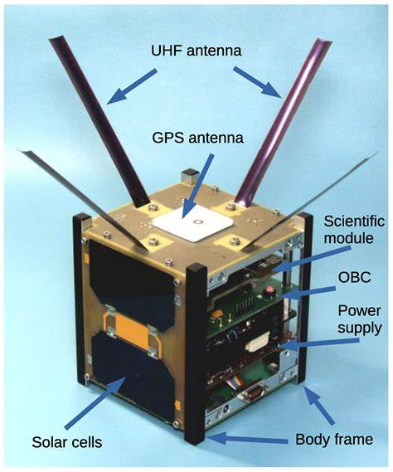

**What "1U" Means**

**"U" stands for Unit** — a standardized cube measuring:

* **10 cm × 10 cm × 10 cm**
* **Maximum mass: ~1.33 kg** (as per CubeSat Design Specification)

**Key Features of a 1U CubeSat**

|  |  |
| --- | --- |
| Feature | Description |
| Compact | Small enough to hold in one hand; fits in a deployer pod called a P-POD |
| Standardized | Conforms to CubeSat design guidelines from Cal Poly/Stanford |
| Low-cost | Much cheaper than traditional satellites; ideal for student and academic missions |
| Modular | Larger satellites can be 2U, 3U, 6U, etc., by stacking more 1U units together |
| Launch-Friendly | Designed to be piggybacked on rockets as secondary payloads |

**Subsystems in a 1U Satellite**

|  |  |
| --- | --- |
| Subsystem | Role |
| EPS (Electrical Power System) | Generates, stores, and distributes power |
| OBC (On-Board Computer) | Coordinates mission logic and subsystem control |
| ADCS (Attitude Determination and Control System) | Maintains orientation |
| Communication | Handles data transmission to/from ground |
| Payload | Scientific instruments or technology demonstration hardware |

**EPS Requirements for a 1U Satellite**

|  |  |  |  |
| --- | --- | --- | --- |
| Requirement | Detail | Conditions | Importance |
| Power Generation | Solar panels to generate 2–5 W | Must handle varying sun angles and eclipse periods | Fundamental for maintaining all subsystems |
| Power Storage | Li-Ion or Li-Po batteries (~10–20 Wh) | Must survive thermal cycling (−40°C to +60°C) and radiation | Ensures power during eclipse or peak loads |
| Power Regulation | MPPT (Maximum Power Point Tracking), LDOs, DC-DC converters | Solar cell efficiency varies by temperature and illumination | Increases power harvesting and stabilizes output |
| Power Distribution | Multiple voltage rails (3.3V, 5V, 12V if needed) | Depends on payload and subsystem needs | Prevents overcurrent/damage to sensitive electronics |
| Protection & Fault Management | Overvoltage, undervoltage, short-circuit protection | Required for safety, especially for shared buses | Increases reliability and satellite lifetime |
| Monitoring & Telemetry | Current, voltage, temperature sensors on critical rails | Works together with the OBC | Enables health monitoring and adaptive power control |
| Redundancy | Optional in 1U, but battery and solar redundancy are desirable | Constraints in volume and mass | Enhances reliability for longer missions |
| Thermal Management | Passive, via heat pipes or coatings | Internal heat from power losses | Maintains component efficiency and safety |

**Suitable Microcontrollers for EPS Control**

Key considerations:

* Radiation tolerance (TID and SEU)
* Low power consumption
* Sufficient peripherals (I2C, SPI, ADC, UART)
* Temperature range (−40°C to +85°C or more)

|  |  |  |  |  |
| --- | --- | --- | --- | --- |
| Microcontroller | Features | Radiation Tolerance | Power | Why Suitable |
| TI MSP430FR5969 | Ultra-low power, FRAM | Up to 50 krad (with shielding) | ~0.4 µA standby | Proven in space missions, excellent low power |
| Microchip ATmegaS128 | Space-grade ATMega | 50–100 krad | 1.8–5.5V | Flight Heritage from CubeSat missions |
| Cypress PSoC 4 | Analog + digital peripherals | Not radiation-hardened | ~1 µA standby | Versatile, but requires shielding |
| ST STM32L4 | ARM Cortex-M4, low power | Limited radiation tolerance | ~100 µA/MHz | Popular in academic CubeSats |
| GOMspace NanoPower P31u | Custom EPS IC with microcontroller | Flight-tested | Integrated | Integrated solution with flight heritage |

**Previously Used Microcontrollers in 1U EPS**

|  |  |  |  |
| --- | --- | --- | --- |
| Microcontroller | Mission | Advantages | Disadvantages |
| MSP430 | *ESTCube-1 (2013), AO-73* | Very low power, used in EPS and ADCS | Not hardened—relies on shielding |
| ATmega128/2560 | *QB50, CanSat, and several student missions* | Simple, well-understood, used in Arduino | Limited computing power, susceptible to SEUs |
| ARM Cortex-M3 (STM32) | *AAUSAT3, GOMX-3* | More processing power, good integration | Needs radiation testing/shielding |
| Rad-Hard LEON3FT | *ESA missions (not 1U due to size)* | Fully space-qualified | Expensive, large, power-hungry |
| GOMspace NanoPower | *Multiple GOMSpace missions (GOMX-1, GOMX-3)* | Complete EPS + OBC integration | Proprietary, less control for DIY projects |

**Comparison and Recommendation**

|  |  |  |  |  |  |
| --- | --- | --- | --- | --- | --- |
| Microcontroller | Radiation Tolerance | Power Efficiency | Flight Heritage | Ease of Use | Overall Suitability |
| MSP430FR5969 | Moderate (with shielding) | ⭐⭐⭐⭐⭐ | ⭐⭐⭐⭐ | ⭐⭐⭐⭐ | ⭐⭐⭐⭐⭐ |
| ATmegaS128 | Good | ⭐⭐⭐ | ⭐⭐⭐⭐ | ⭐⭐⭐⭐ | ⭐⭐⭐⭐ |
| STM32L4 | Low | ⭐⭐⭐⭐ | ⭐⭐ | ⭐⭐⭐⭐ | ⭐⭐⭐ |
| NanoPower P31u | Excellent | ⭐⭐⭐⭐ | ⭐⭐⭐⭐⭐ | ⭐⭐ | ⭐⭐⭐⭐ |

**Recommendation:**  
**MSP430FR5969** is a strong option to consider due to its ultra-low power consumption, flight heritage, and resilience when paired with basic shielding.

**EPS–OBC Interface**

**Common Interfaces:**

* **I2C:** Widely used; low pin count
* **CAN Bus:** More robust, error-resistant
* **UART/RS-485:** Simple, easy to implement
* **SPI:** Fast but not ideal for multi-device busses

**EPS-OBC Interaction:**

|  |  |  |
| --- | --- | --- |
| Function | How It Works | When It's Used |
| Power monitoring | EPS sends telemetry (voltage, current, battery state) via I2C/UART | Periodically, e.g., every 5–10 seconds |
| Command execution | OBC sends commands to EPS: enable/disable rails, reset system | Faults, mode changes (science vs safe mode) |
| Safety mechanisms | EPS independently powers off subsystems on overcurrent | Instantly, with interrupt |
| Wake-up events | EPS wakes up OBC based on timer or event (e.g., sunlight) | Eclipse exit or timed transmission |